A SINGLE-PHASE TRANSFORMERLESS INVERTER WITH CHARGE PUMP CIRCUIT CONCEPT FOR GRID-TIED PV APPLICATIONS
ABSTRACT
This paper proposes a new single-phase transformerless photovoltaic (PV) inverter for grid-tied PV systems. The topology is derived from the concept of a charge pump circuit in order to eliminate the leakage current. It is composed of four power switches, two diodes, two capacitors, and an LCL output filter. The neutral of the grid is directly connected to the negative polarity of the PV panel that creates a constant common mode voltage and zero leakage current. The charge pump circuit generates the negative output voltage of the proposed inverter during the negative cycle. A proportional resonant control strategy is used to control the injected current. The main benefits of the proposed inverter are: 1) the neutral of the grid is directly connected to the negative terminal of the PV panel, so the leakage current is eliminated; 2) its compact size; 3) low cost; 4) the used dc voltage of the proposed inverter is the same as the full-bridge inverter (unlike neutral point clamped (NPC), active NPC, and half-bridge inverters); 5) flexible grounding configuration; 6) capability of reactive power flow; and 7) high efficiency. A complete description of the operating principle and analysis of the proposed inverter are presented. Experimental results are presented to confirm both the theoretical analysis and the concept of the proposed inverter. The obtained results clearly validate the performance of the proposed inverter and its practical application in grid-tied PV systems.

BLOCK DIAGRAM FOR PROPOSED SYSTEM
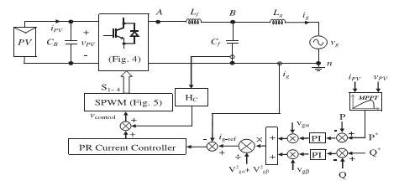
Fig. 1. Control block diagram of the proposed single-phase grid-tied inverter based on single-phase PQ theory
DESIGNG SOFTWARE AND TOOLS:
MAT LAB /SIMULATION Software and simu power systems tools are used. Mainly control system tools, power electronics and electrical elements tools are used.

